# 

# Application Note- AN001

# Creating a custom glitch/drive sequence

# Updated: March 02, 2023

# Creating a custom glitch/drive sequence

In this particular case, a customer requested to customize a sequence of events over a period of a few seconds. This was required to simulate a fault situation that had been observed when their PCIe device was connected to a particular host.

As the shortest duration was ~200ms, and total accuracy was not required, we can do this with a simple script of command to the module.

# Customer Required Sequence

Below is the sequence of events that the customer requested.

REFCLK 12v_EN

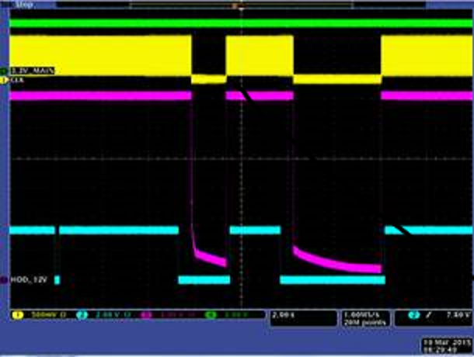

PERST#

There are three channels under observation are 12V_EN, REFCLK and PERST. Each signal needs to change state at a specific time in relation to each other, in order to recreate the failure scenario.

# Results

Running the script included in the app note, we recreate the customer pattern

Using a scope and 3 probes. We observe the signals behaviour and captured the image of the sequence of the events

REFCLK 12V_EN PERST#



 